**CODING ASSESSMENT-03**

**CAR RENTING SYSTEM**

**DATABASE CREATION**

Create database CarrentalSystem;

USE CarRentalSystem;

**SQL SCHEMA**

**1.Vehicle Table**

create table Vehicle (

Vehicle_Id int primary key,

Make varchar(100),

Model varchar(200),

Year int,

Daily_Rate Decimal(10, 2),

Status enum ('1', '0'),

Passenger_Capacity int,

Engine_Capacity int);

**2.Customer Table**

create table Customer (

Customer_Id int primary key,

First_Name varchar(100),

Last_Name varchar(100),

Email varchar(100),

Phone_Number varchar(20));

**3.Lease Table**

create table Lease (

Lease_Id int primary key,

Vehicle_Id int,

Customer_Id int,

Start_Date date,

End_Date date,

type enum('DailyLease', 'MonthlyLease'),

foreign key (vehicle_Id) references Vehicle(vehicle_Id),

foreign key (customer_Id) references Customer(customer_Id));

**4.Payment Table**

create table Payment (

Payment_Id int primary key,

Lease_Id int,

Payment_Date date,

Amount decimal(10, 2),

foreign key (lease_Id) references Lease(lease_Id));

**insert values**

insert into Vehicle values

(1,'Toyota', 'Camry', 2022, 50.00, '1', 4, 1450),

(2,'Honda', 'Civic', 2023, 45.00, '1', 7, 1500),

(3,'Ford', 'Focus', 2022, 48.00, '0', 4, 1400),

(4,'Nissan', 'Altima', 2023, 52.00, '1',7, 1200),

(5,'Chevrolet', 'Malibu', 2022, 47.00,' 1',4, 1800),

(6,'Hyundai', 'Sonata', 2023, 49.00,'0', 7, 1400),

(7,'BMW', '3 Series', 2023, 60.00, '1', 7, 2499),

(8,'Mercedes', 'C-Class', 2022, 58.00, '1', 8, 2599),

(9,'Audi', 'A4', 2022, 55.00, '0', 4, 2500),

(10,'Lexus', 'ES', 2023, 54.00, '1', 4, 2500);

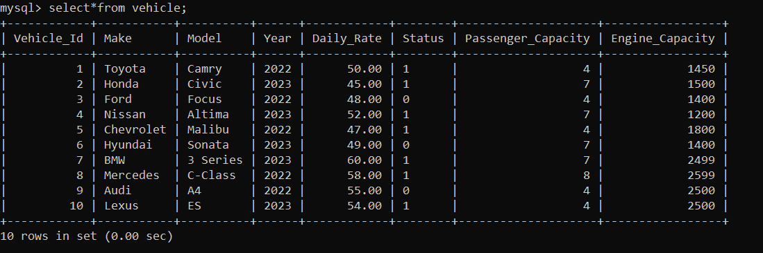

Insert values into Customer Table

insert into Customer values

(1,'John', 'Doe', 'johndoe@example.com', '123-456-7890'),

(2,'Jane', 'Smith', 'janesmith@example.com', '987-654-3210'),

(3,'Robert', 'Johnson', 'robert@example.com', '555-123-4567'),

(4,'Sarah', 'Brown', 'sarah.williams@example.com', '789-012-3456'),

(5,'David', 'Lee', 'david.jones@example.com', '111-222-3333'),

(6,'Laura', 'Hall', 'laura@example.com', '123-456-7890'),

(7,'Michael', 'Davis', 'michael@example.com', '987-654-3210'),

(8,'Emma', 'Wilson', 'emma@example.com', '555-123-4567'),

(9,'William', 'Taylor', 'william@example.com', '789-012-3456'),

(10,'Olivia', 'Adams', 'olivia@example.com', '111-222-3333');

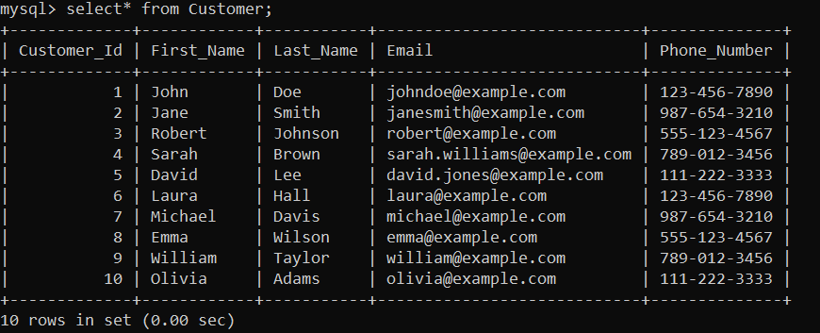

Insert values into Lease Table

insert into Lease values

(1, 1,1, '2023-01-01', '2023-01-10', 'DailyLease'),

(2, 2,2, '2023-02-01', '2023-03-01', 'MonthlyLease'),

(3, 3,3, '2023-03-15', '2023-03-30', 'DailyLease'),

(4, 4,4, '2023-04-01', '2023-05-01', 'MonthlyLease'),

(5, 5,5, '2023-05-10', '2023-05-20', 'DailyLease'),

(6, 6,6, '2023-01-09', '2023-01-20', 'DailyLease'),

(7, 7,7, '2023-06-11', '2023-07-01', 'MonthlyLease'),

(8, 8,8, '2023-07-15', '2023-07-25', 'DailyLease'),

(9, 9,9, '2023-08-21', '2023-09-21', 'MonthlyLease'),

(10, 10,10, '2023-11-12', '2023-11-22', 'DailyLease');

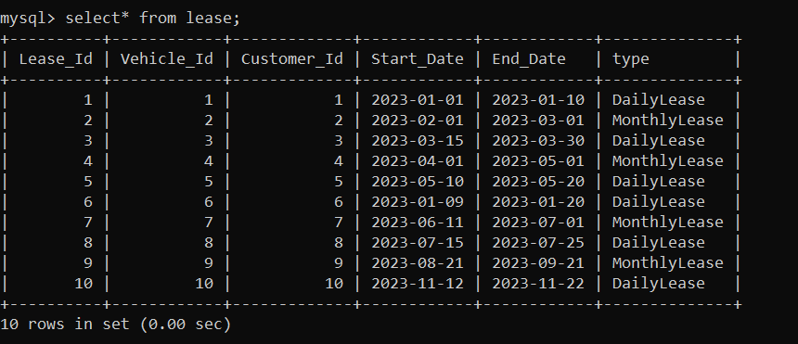

Insert values into Payment Table

insert into Payment values

(1,1,'2023-01-05', 55.00),

(2,2,'2023-02-15', 120.00),

(3,3,'2023-03-20', 70.00),

(4,4,'2023-04-10', 150.00),

(5,5,'2023-05-15', 40.00),

(6,6,'2023-01-12', 60.00),

(7,7,'2023-03-25', 80.00),

(8,8,'2023-05-18', 45.00),

(9,9,'2023-02-28', 90.00),

(10,10,'2023-04-20', 100.00);

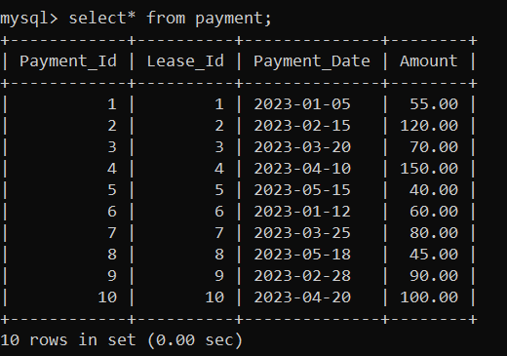

**SQL QUERIES**

1.update daily rate for a Mercedes car to 68

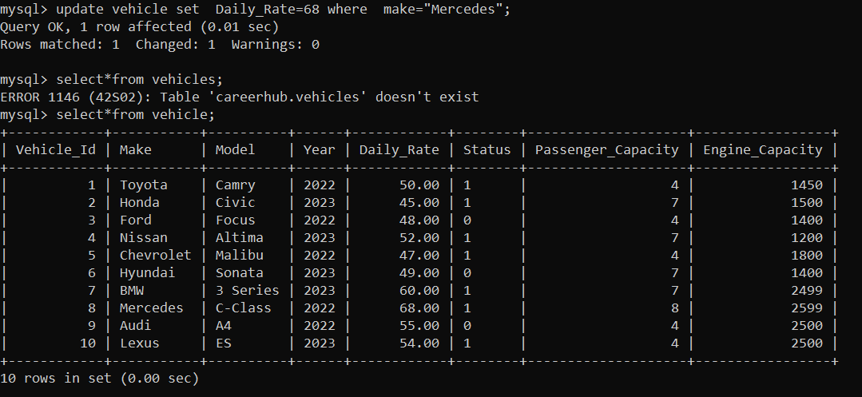

2. Delete a specific customer and all associated leases and payments.

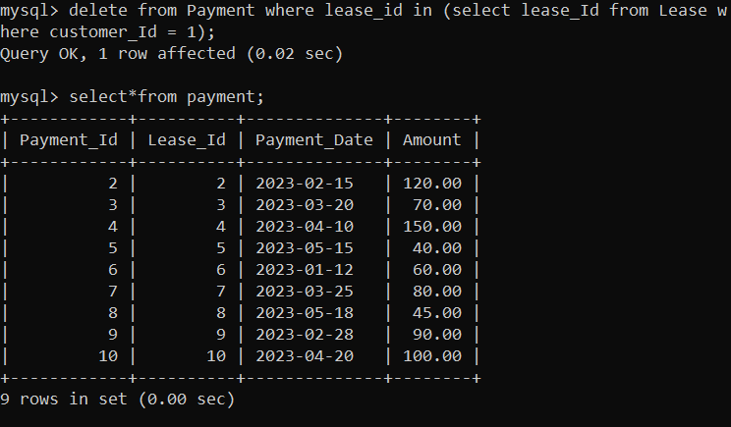

3. Rename the "paymentDate" column in the Payment table to "transactionDate"

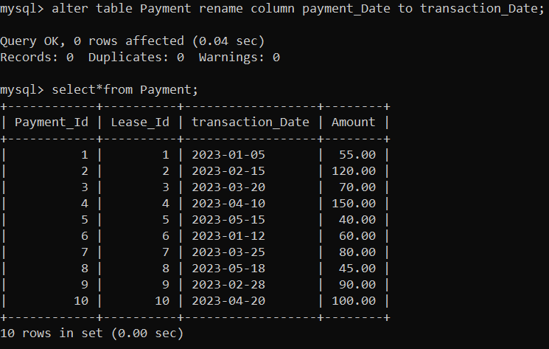

4. Find a specific customer by email

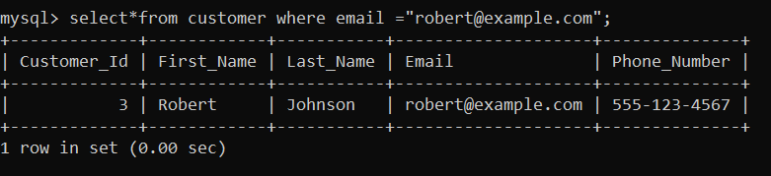

5. Active leases for a specific customerc



6. Find all payments made by a customer with a specific phone number.

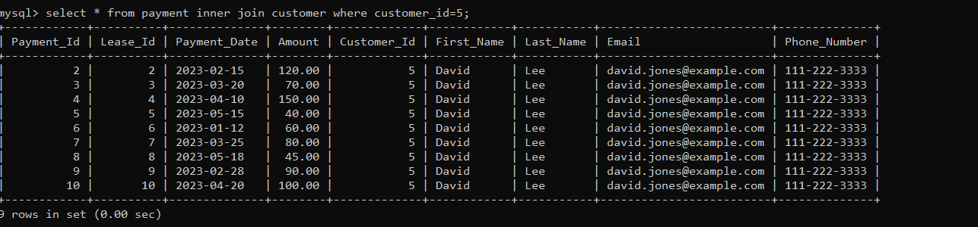

7. average daily rate of all available cars

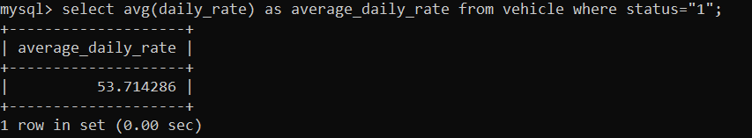

8. car with the highest daily rate

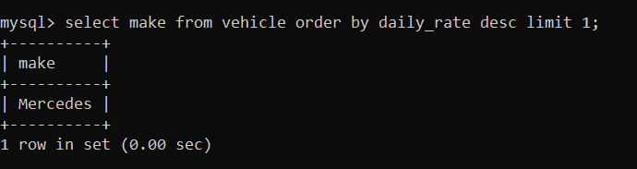

9. Retrieve all cars leased by a specific customer.

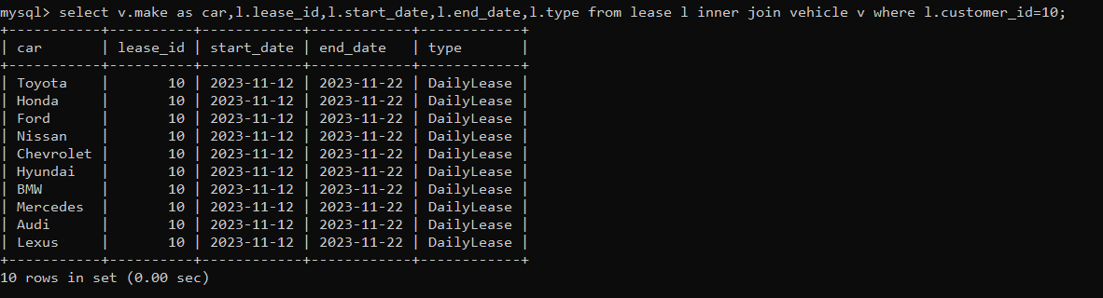

10. details of the most recent lease

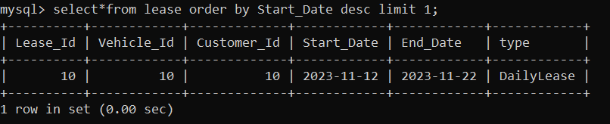

11. all payments made in the year 2023

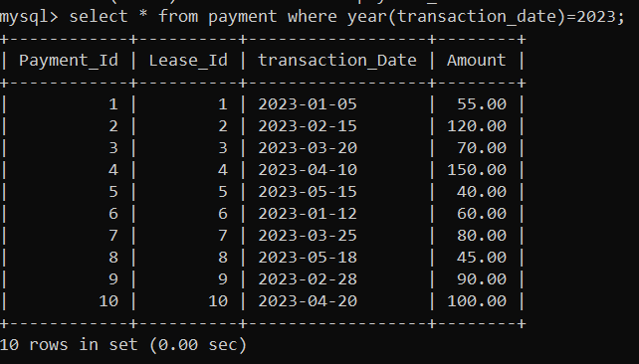

12. customers who have not made any payments



13. Retrieve Car Details and Their Total Payments.

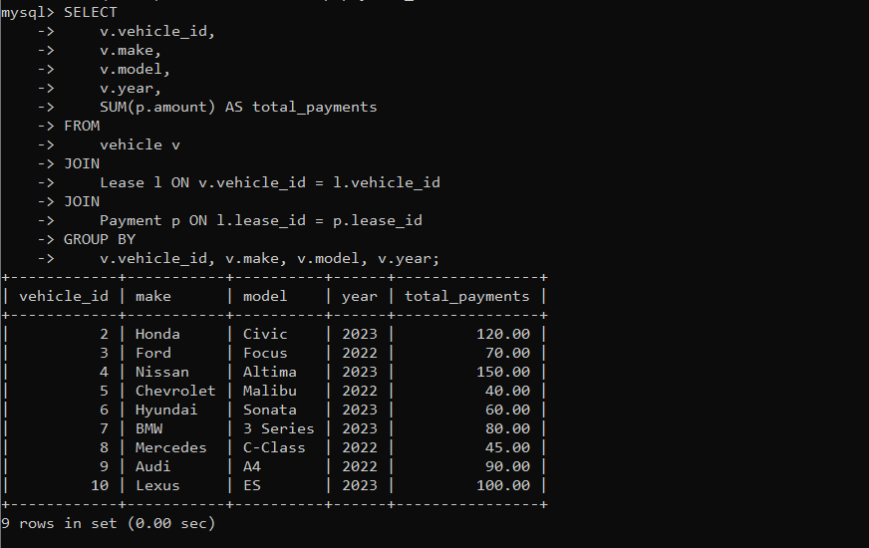

14. Calculate Total Payments for Each Customer.

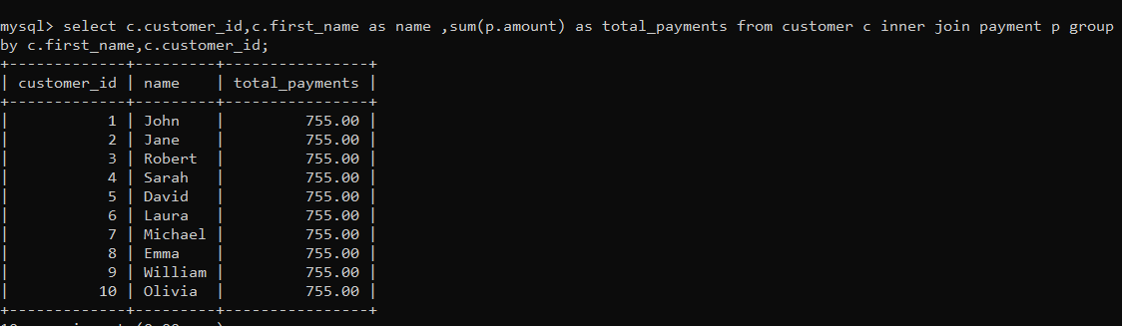

15.List Car Details for Each Lease.

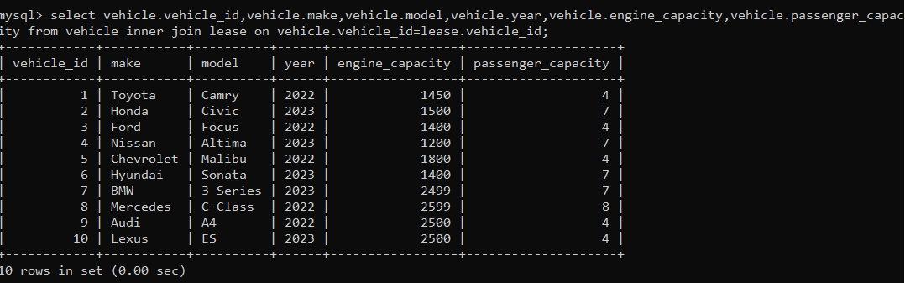

16.Retrieve Details of Active Leases with Customer and Car Information.

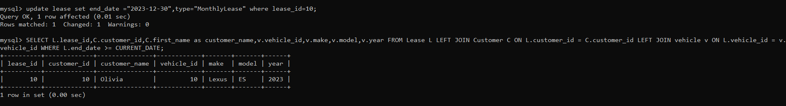

17. Find the Customer Who Has Spent the Most on Leases.

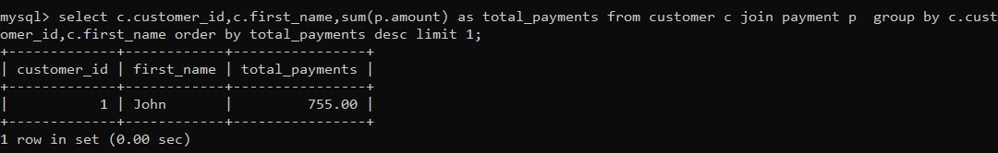

18.List All Cars with Their Current Lease Information.

